MAD MAX: THE GAME Documentation

**Introduction:**

MAD MAX : THE GAME is a zombie survival game where our hero has sent himself to the underworld and must evade zombie swarms for as long as possible. The game is played by tilting the game board (PIC32) and pressing the buttons on it while viewing the OLED as a display.

**Hardware Requirements:**

* Digilent PIC32MX795F512L board
* PmodACL ADXL345
* PmodOLED
* ADC Joystick for Player 2

**Board Setup:**

Please set up your PIC32 and hardware layout using the ADXL345 and PmodOLED as shown in the picture below or with the Joystick attachment:

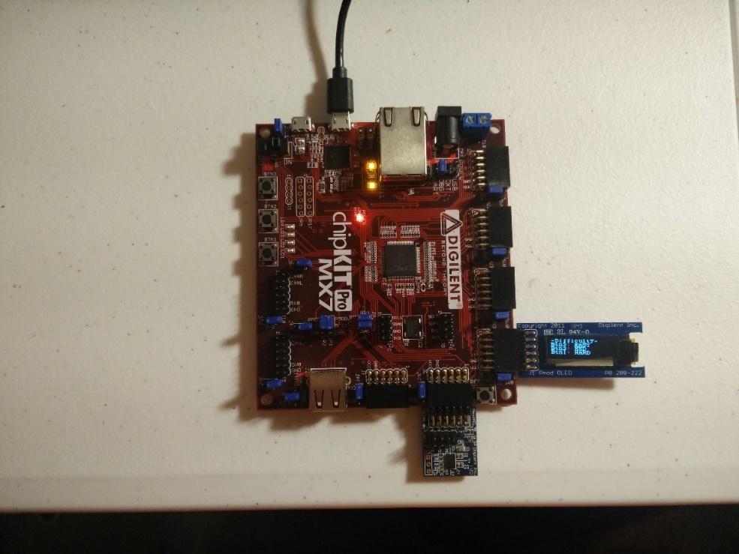 OR 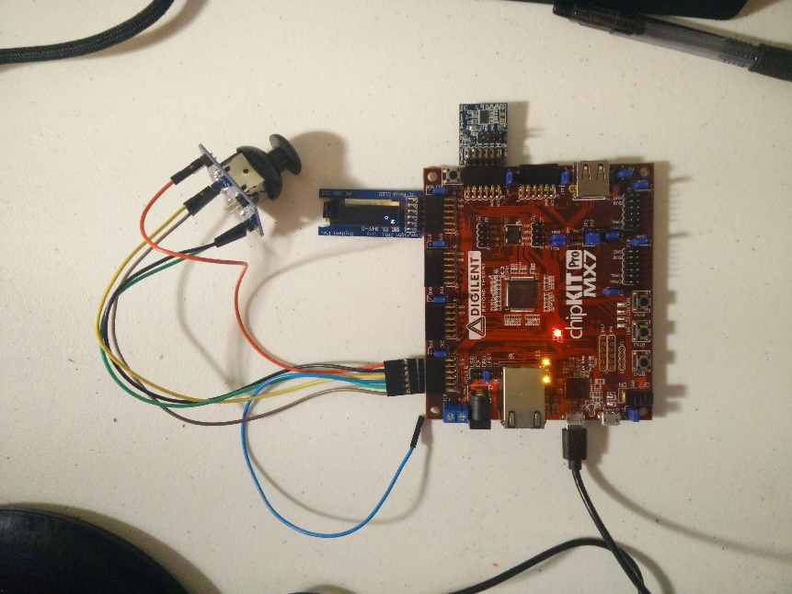

The PmodOLED has to be in the JD header shown but the ADXL can be in either JE or JF as it builds off of HW6 code for extra credit.

Take note that the ADXL is connected directly to the PIC32 and you should use this configuration for best results. This allows for a hard-set orientation for tilting the accelerometer where tilting the PIC32 while viewing the OLED at a straight angle will produce a motion akin to what you would expect in real life.

To run my Two Player game, you need to have the Joystick connected to the default JA in the configuration of LAB2 using the Medusa cable.

**Note to TA:**

I believe I have completed and implemented this project to the full requirements of the rubric and lab document. This includes External interrupts for the ADXL, velocity in game, random locations, and the zombies. If there is any reason that you may think something was not done correctly and cannot read my code effectively, please contact me at my email above so I may schedule a time to come and show you.

My ADXL Tap initialization is done by the project specification but not in the locations the original project document specified. It was done at the suggestion of TA Nahush and initializes basic Tap ability in ADXL INIT and then uses the bool ADXL345_SingleTapDetected () for tap detection instead. External Interrupts as the project specification wants is also implemented in ADXL345.c as it wanted.

**QUICK START:**

Lay board completely flat on table to start off with or hold steady in hand to avoid accidental taps.

Begin by pressing BTN1 to choose Player1 mode. This is the mode our project is based on and what you should grade.

Do not tap or shake/move the board now. A CINEMATIC video will begin to immerse player in story and Hero of our game. Your name will appear at end in style.

Press the correlating button (1 to 3) to get different Difficulty Level and zombie generation. I recommend Easy. You will get a playing field with values of a # followed by S and F vertically on right hand side. The top value is the time elapsed and also the score in seconds followed by powerups of freezing the zombies for F and slowing the zombies for S. Press BTN 2 for Slow down and BTN 1 for Freeze powerup.

Tilt the board at moderate levels for medium speed and tilt at extreme 45 angle for fast velocity across game board.

The Zombies will come at you but not in straight line thanks to game code. Use powerups and movement to win the game.

Zombie spawn and Tap to reset is only enabled after 6s due to reasons in detailed explanation below.

High Score board is available at the end of every game single player game to keep track of user score.

**DETAILED HOW TO:**

MAD MAX : THE GAME is a game that will bring the user to the main game mode screen after running it in MPLAB X. Here, you can choose to enter two different modes. Note that you cannot switch between Two Player or Single Player modes while in game. You must reset the game through MPLAB X for this. Single Player mode is what the project is based on so this is not a problem. You can test my Two Player mode for extra credit.

Single Player mode enables CINEMATIC story, difficulty, powerups, delayed zombie spawn, and multiple paly through to get a higher score while time elapses. Every death/infection will bring player back to the difficulty screen after the first death. Taps will also work to bring player back to difficulty screen.

Two Player mode allows the use of both the ADXL Accelerometer and ADC Joystick at the same time. There is no CINEMATIC video, high score or any standard features of Single Player mode. Player1 will control the Human through the ADXL Accelerometer by tilting as he would in Single Player mode. Player 2 will control a single zombie through the ADC Joystick like in LAB3. The human performs the same as in the other mode and will bounce while the Zombie will not have any bounces. The player controlling the zombie has continuous movement where he will continue in last direction joystick was pointed in. After every death, the game will restart back to exactly the same playing field with no extras. There is no score as well. This extra feature mode doesn’t make sense to include a high score chart, or any powerups as we have two real players using the controls.

Remember, you only have one chance to choose Single Player or Two Player mode at the beginning of the game boot. You will have to reset game to change this.

The rest of the instructions will pertain to the Single Player game mode that the project document prescribes.

When you begin the game, after the required two second boot splash screen is done. The game will begin its CINEMATIC MODE where it will do a quick scroll of the TA’s name (KABIR) in stylized string characters. It will then do a ‘Star Wars’ like scrolling effect again, but this time with the STORY of the game that we are playing again. This will give a quick backstory to the ‘problem’ and give us insight on our hero we will be playing. The STORY is included below as well in case you want a fuller text copy for easy reading. Tap at any time during this and hold it to skip the entire CINEMATIC mode.

This mode will only appear ONCE on initial running in MPLAB X and will appear if user does not make a selection on difficulty screen for 9 seconds. This is based off real games where no user input on main menu will go into these nice cinema screens. Simply tap to enter difficulty mode again.

The difficulty screen is the next state after the CINEMATIC MODE and is the general default state you will come back to. Press BTN1 for HARD mode, BTN2 for MED mode and BTN 3 for EASY mode. The mode differences are shown below:

EASY MODE:

* 1 Zombie and moves at very slow speed towards Hero. (1 to 4 ratio movement)

MED MODE:

* 2 Zombies and move at average speed towards Hero (1 to 3 ratio movement)

HARD MODE:

* 3 Zombies and move at fast speed towards Hero due to (1 to 2 ratio movement)

EASY Mode is highly recommended for playing. It is possible to play the other modes but they are very hard. I included extra credit pieces of code in my game such as the multiple zombies and their ratio of movement code as a proof of concept mainly. It would not have been as viewable to the TA in HARD mode that the Zombies move ‘smarter’ thanks to more processing steps if I increased this amount only by a little. Therefore the difficulty gets extreme to show off these small details.

Ratio of movement depends on the difficulty chosen. It is implemented for extra credit. When it is on EASY, the zombie will only update itself and ‘move’ at a ratio of 1 zombie move for every 4 movements the human can make. This ratio gets decreased the greater the difficulty level so the Zombie becomes smarter because it gets more processing time to go through the movement loops.

The Zombies will spawn in the underworld after about 7 seconds. During that time, the Hero may move around as they wish. Both the Hero and every zombie spawn randomly in different locations. The spawning locations for the Zombies have stronger weight towards the edges rather than the middle parts but this is not always the case to keep it more ‘random’.

It is possible in **rare** cases for the game to end immediately on zombie spawning if they are in the exact location during that interval. This was kept in the game and not recalculated through a recursive loop for realism as well. Where you may think of it as a zombie reaching out from the ground as the Hero walks over it and gets infected.

The Layout of the field can be seen below. The entire left hand side of the screen up until the edge where you see the 5,S,F is the playing field.

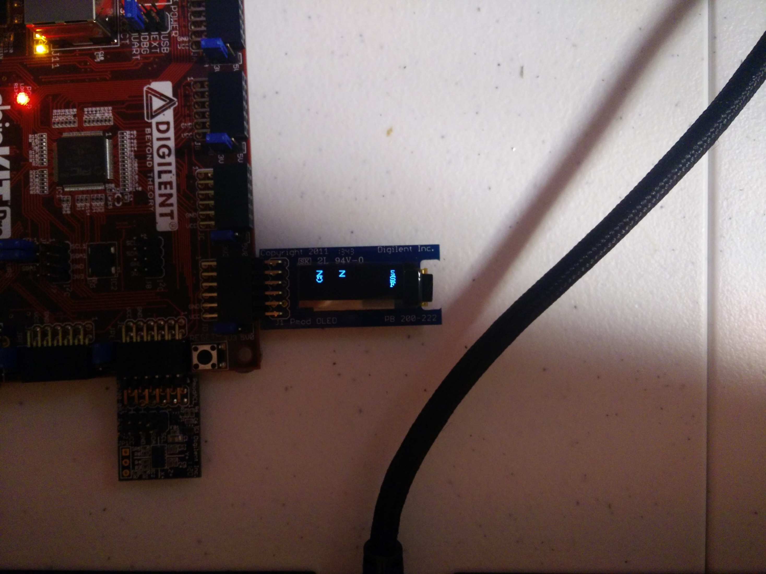

The first value on the top right, the ‘5’ in this case is the score which is also the elapsed time in seconds. It will steadilly increase upwards from 0 until the zombie infects our hero.

The second value on the top right, the ‘S’ in this case is an extra-credit in game power up which stands for ‘Slow down’. This powerup can be enabled by pressing BTN2 at any time while the game is playing. It has a duration of 5seconds and is only available once. The moment the BTN2 is pressed, the S will be replaced by a flashing numerical value equivalent to the countdown to 5 before your powerup is done. After its use, the letter ‘S’ no longer appears and can’t be activated anymore.

The third value on the middle right, the ‘F’ in this case is another extra credit in game power up which stands for ‘Freeze’. This powerup is enabled by pressing BTN1 at any time while the game is playing. It also has a duration of 5seconds with the flashing numerical countdown.

You can see the numerical countdown for both S and F just having started and have four seconds to go below as they have elapsed one second. They can both be activated at the time same time as with most games with powerups, this is up to user discretion but using both at the same time is not a smart move in playing.

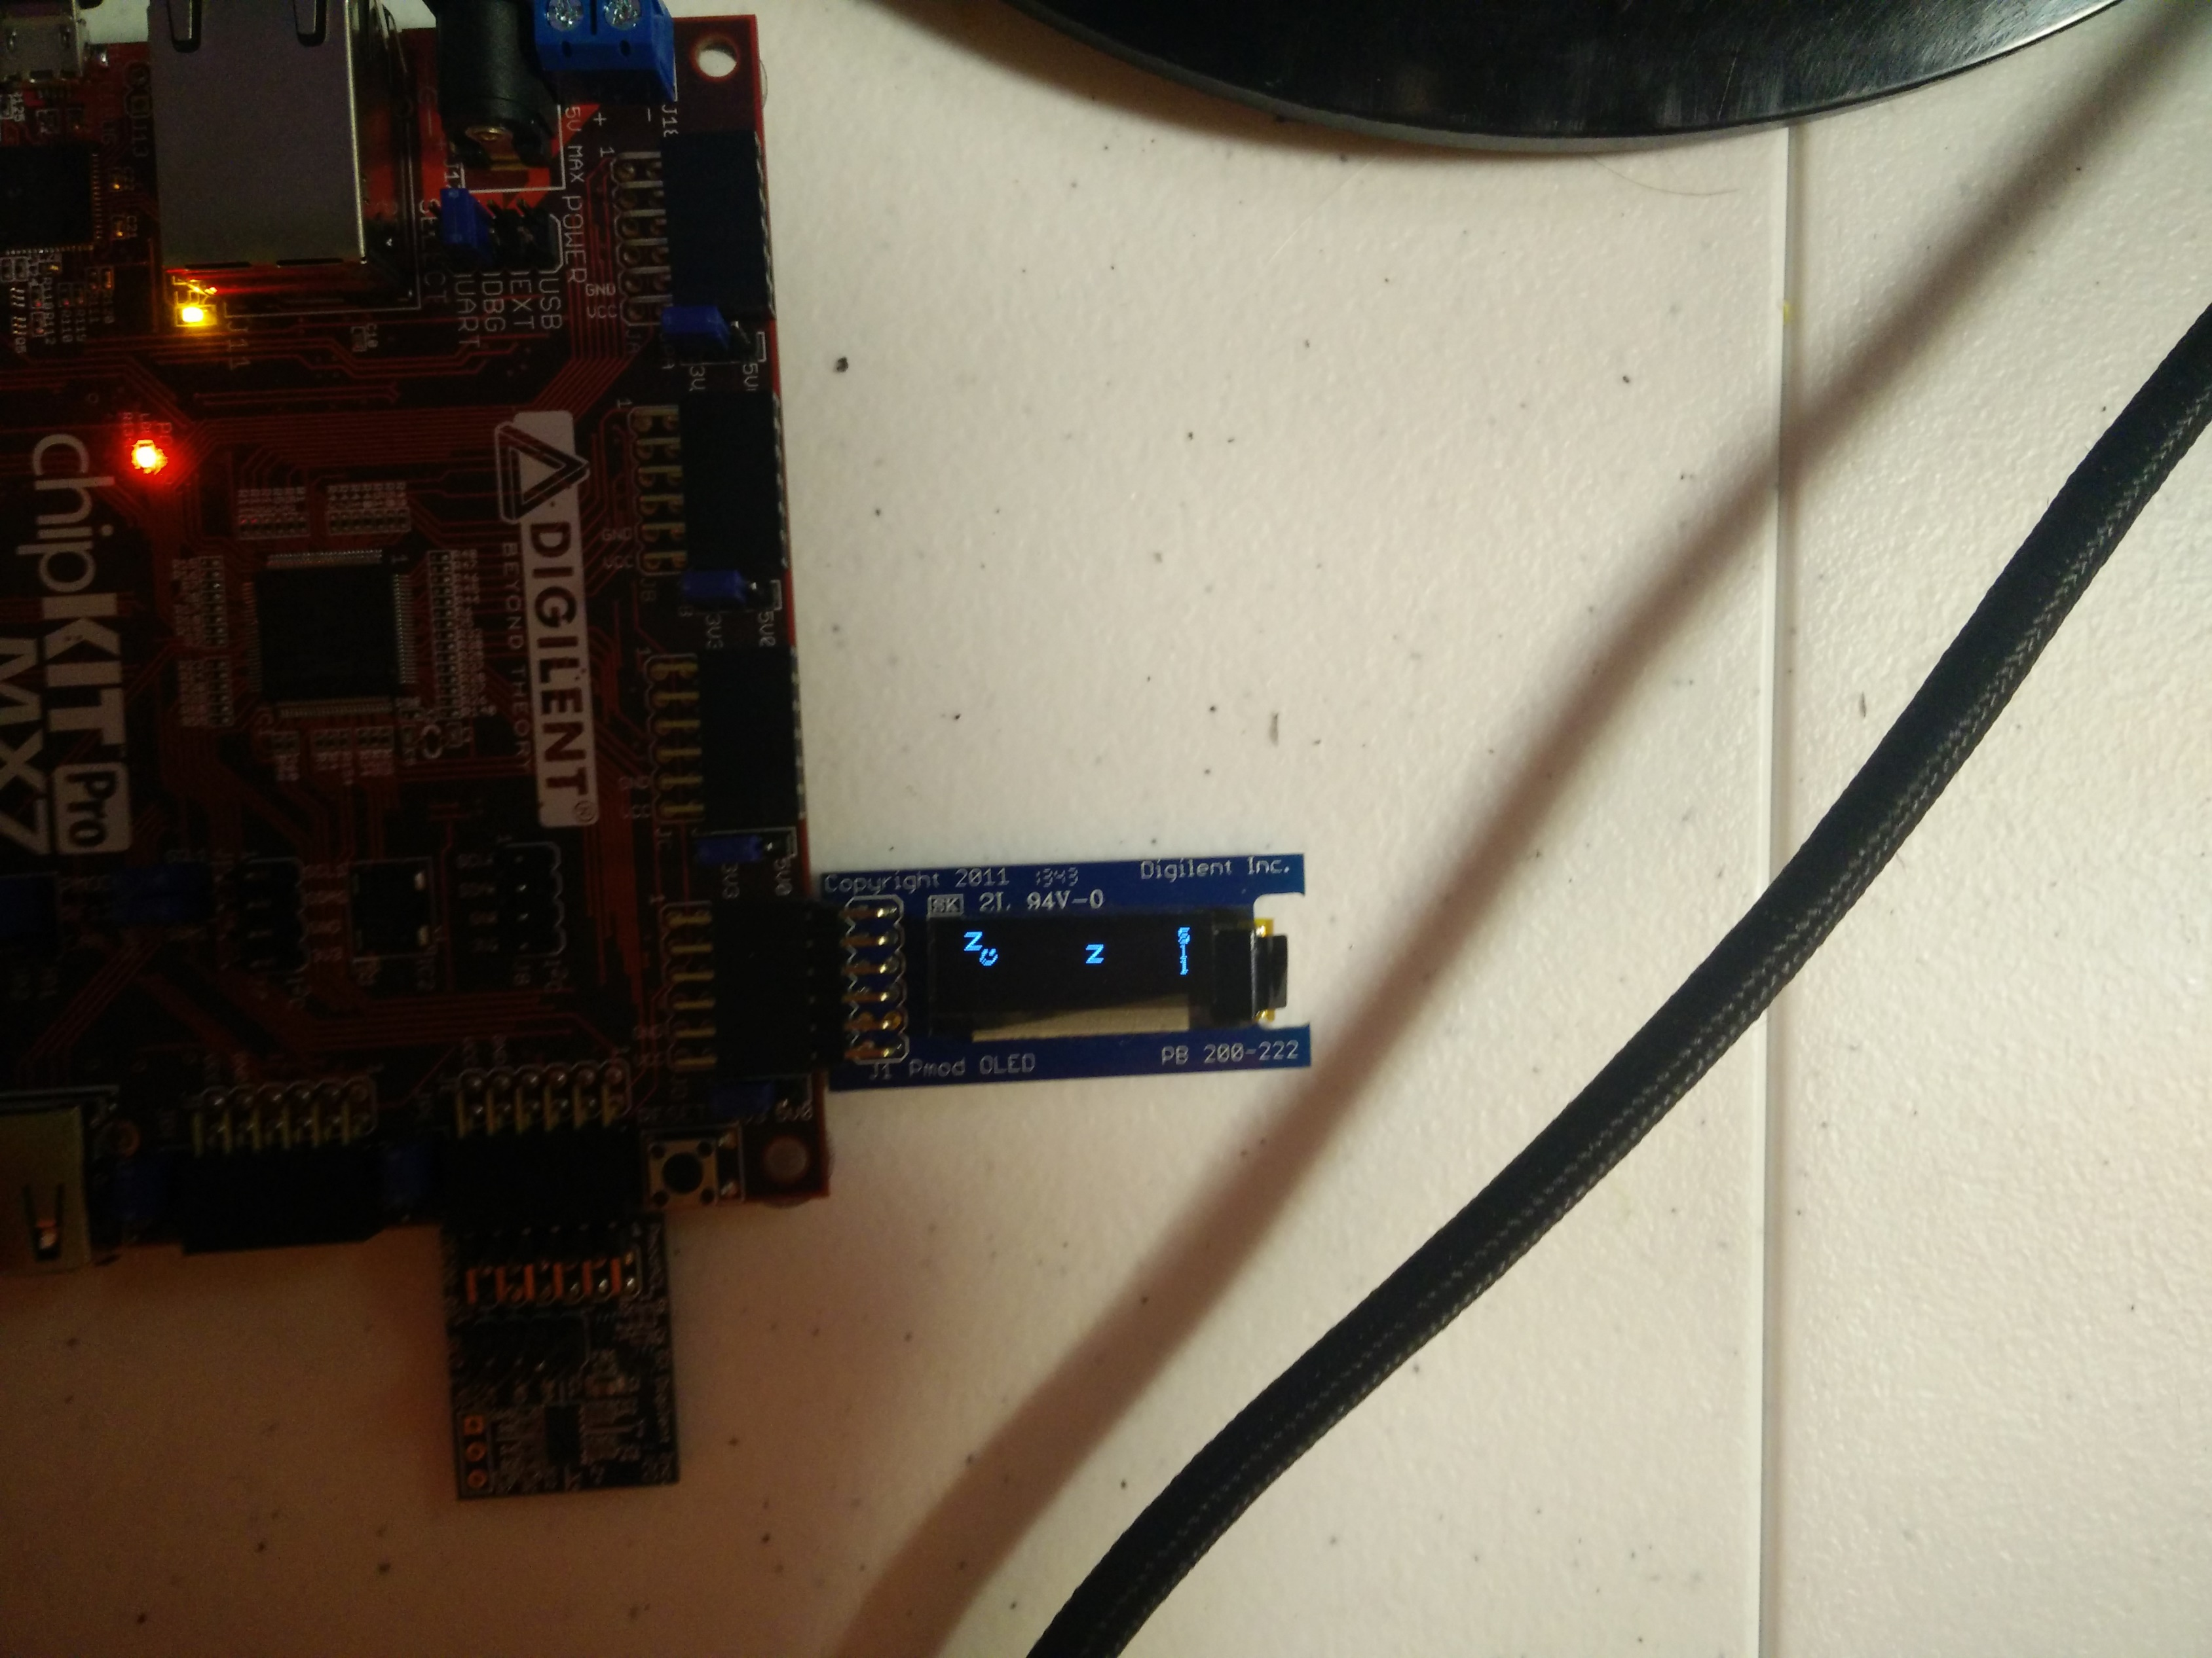

The smiley face seen in the OLED above represents our Hero whereas the Z symbol represents the Zombie(s) that are out. We currently are playing in medium difficulty so we have two zombies following the Hero.

You may tap the ADXL at 6s+ during the game to quit it and return to the difficulty menu. This artificial denial of tap registration was due in part because sometimes pressing the button to select difficulty can also be seen as a tap when the game mode switches. The game rubric and project allowed for free implementation of this in creative ways which is why I decided to only make tapping available after 6s which is just after zombies appear to be more cinematic to how games are played in real life.

The Game also implements an extra-credit High Score counter after every ‘Game OVER’ state is initiated whether by the Hero being infected or by a Tap. This score is recorded and compared to all previous attempts (during the MPLAB Runtime) to give indication for how the user is doing. The scores are of course in seconds survived by the Hero and does not factor difficulty into it.

**TIPS:**

The Zombies in the game are coded in a fashion that you can take advantage of to get a great high score. During every iteration through my zombie movement loop, a random value is generated using a new srand seed every time (to get near truly random values) that where 50+% of the time, the Zombie will move horizontally or vertically in positive or negative directions. The last 50% of the time, the Zombie will actually then compare position values to the Hero and move towards him. This was done because the loop through for zombie movement was too fast and smart and so this random movement that will still move it towards the Hero was added for added realism. The idea is that zombies don’t move straight or completely towards in movies.

The game still follows project specification of having the Zombie move towards the human as the sheer amount of loops the game runs is such that the Zombie will always end up inching closer and closer towards the human.

Using these ideas of semi-random movement and the given Freeze and Slow powerup, you may time your movements to ‘fly’ across the map at great velocity (equivalent to tilt) right when the zombies are about to come at you or use a powerup by gently tapping the BTN# if you are near infection.

Do note that the game supports a max tilt of approximately +-45 degrees from the horizontal in any direction. During TA demonstrations, I noted that you were not tilting my board as required to get the speed velocity needed. The average ‘bowl’ swivel tilt will only move the Hero at medium to slow speeds whereas an extreme 45 degree tilt will move him fast around the board.

Code comment blocks note which Switch Cases or Functions feature what type of Extra credit implementation to make it easier for you to find where and what I did.

**STORY:**

Below is the lore of the game story as shown in the game but in better text representation here.

There once was a man named MAX who was king of the Zombies! He had fame, Power, and Wealth beyond your wildest Dreams. Before he died, These were his final words:

“My fortune is yours for the taking, but you have to find it first. I left all I own down in the Underworld.”

Ever since then, All the HEROs have begun their journeys into the Underworld to find MAX’s treasure that would make their dreams come TRUE!

This Game is the story of one such hero who ventured into the Underworld to find the treasure of MAD MAX!

The general story behind the game is that a king named MAX died and left all his riches in the Underworld where Zombies live promising Heros who can survive to get his treasures. Our game is played as one of the heros who braves the Underworld to try and win the treasures.

As you may expect, none of this really plays much into the game we’ve created, but I felt it needed to create an experience like those of real games in giving a backstory to explain why we ended up where we are chased by zombies.

**EXTRA CREDIT:**

The following are extra-credit implementations of the game I have created:

* ADXL Auto detects SPI Channels and will produce error if not plugged. Builds off previous code.
* Scrolling CINEMATIC Story TEXT that exits by tapping
* Cool ASCII/String of TA name KABIR in beginning
* Multiple Zombies (Code can make as many as I want by changing one value)
* Difficulty Levels and Selection Screen
* Re-generative CINEMATIC screen during 9s pauses in Difficulty Screen for Game Immersion
* Zombies operate in semi-realistic random pattern by using random movement 50% of the time to make them seem dumb and bad at walking straight. Implemented Zombie limp essentially.
* Ratio of Movement depending on difficulty selected. This changes Zombie speed/behavior towards human where harder difficulty updates zombie movement ratio to human movement faster.
* High Score Board at End of Game keeps track of score and compares values.
* Special Effects. LED lights flash and screen transition flashes for Immersion and look. LED lights near button indicate difficulty level by how many lights are on (1 light for EASY, 2 for MED, and 3 for HARD) and will flash through different periods of game code.
* Two Player Mode Implementation
* Additional support for ADC Joystick reads in 2-player mode